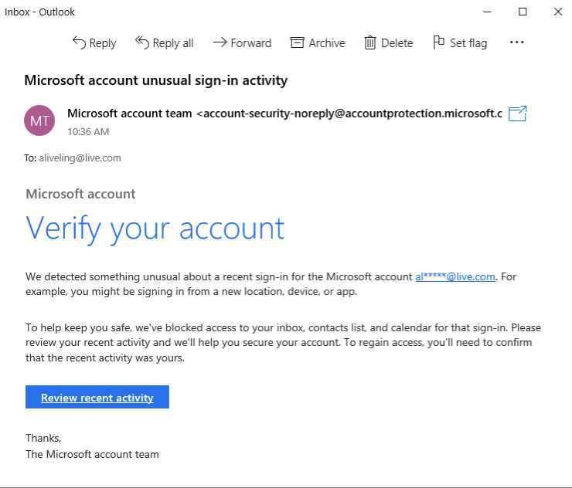

1. Sender's Email Address: The sender's display name is "Microsoft account team", which seems legitimate. However, the actual email address is "account-security-noreply@accountprotection.microsoft.c", which is a sign of spoofing. The address uses a common tactic of adding a non-existent or altered subdomain, and in this case, the ".com" is missing at the end, making it an invalid domain.

2. Email Headers: The email headers would likely show that the email did not originate from a legitimate Microsoft server, but rather from an unauthorized source, which is a common discrepancy in phishing emails.

3. Suspicious Links or Attachments: The email contains a link presented as a button that says "Review recent activity". This link is designed to trick the user into clicking it. Clicking this link would likely lead to a fraudulent website that mimics the official Microsoft login page.

4. Urgent or Threatening Language: The subject line, "Microsoft account unusual sign-in activity", and the body of the email use language to create a sense of urgency and fear. Phrases like "we've blocked access to your inbox" and the need to "regain access" are meant to panic the user into immediate action without thinking.

5. Mismatched URLs: While not fully visible, the URL behind the "Review recent activity" button is almost certainly not a legitimate Microsoft URL. A quick hover over the button would reveal a malicious or unrelated web address.

6. Spelling or Grammar Errors: The email appears to have no obvious spelling or grammar errors, which can make it more convincing to a user. The mail generated totally sophisticated and phishers often create emails with professional language.

7. Summary of Phishing Traits:

* Spoofed Sender: The sender's email address is a close but incorrect imitation of a legitimate one.
* Sense of Urgency: The email uses alarming language about "unusual activity" and blocked access to force a quick response.
* Malicious Call to Action: It includes a prominent button that directs the user to a fraudulent website.
* Deceptive Content: The content aims to make the user believe their account is at risk, prompting them to provide their credentials on a fake site.